

|  |
| --- |
| **ASSIGNMENT**  *Launching instances with Cloud-init* |

**Launching instances with Cloud-init**

* **Configuring Security group for a Webserver.**

1. *Open the Amazon VPC console at* [*https://console.aws.amazon.com/vpc/*](https://console.aws.amazon.com/vpc/)*.In the navigation pane, choose Security Groups. Enter a name of the security group and provide a description. Select the ID of your VPC from the VPC menu. Under Security group rules, provide inbound and outbound rules required for a webserver and choose Yes, Create.*

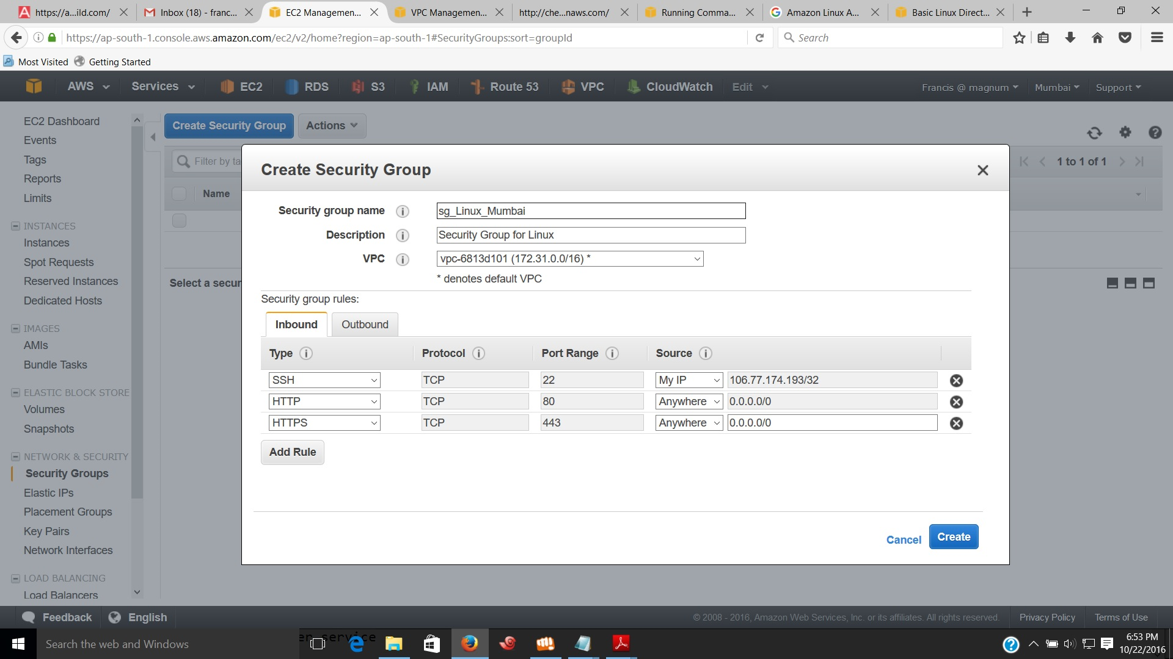

1. *Select newly created Security Group and verify the rules*.

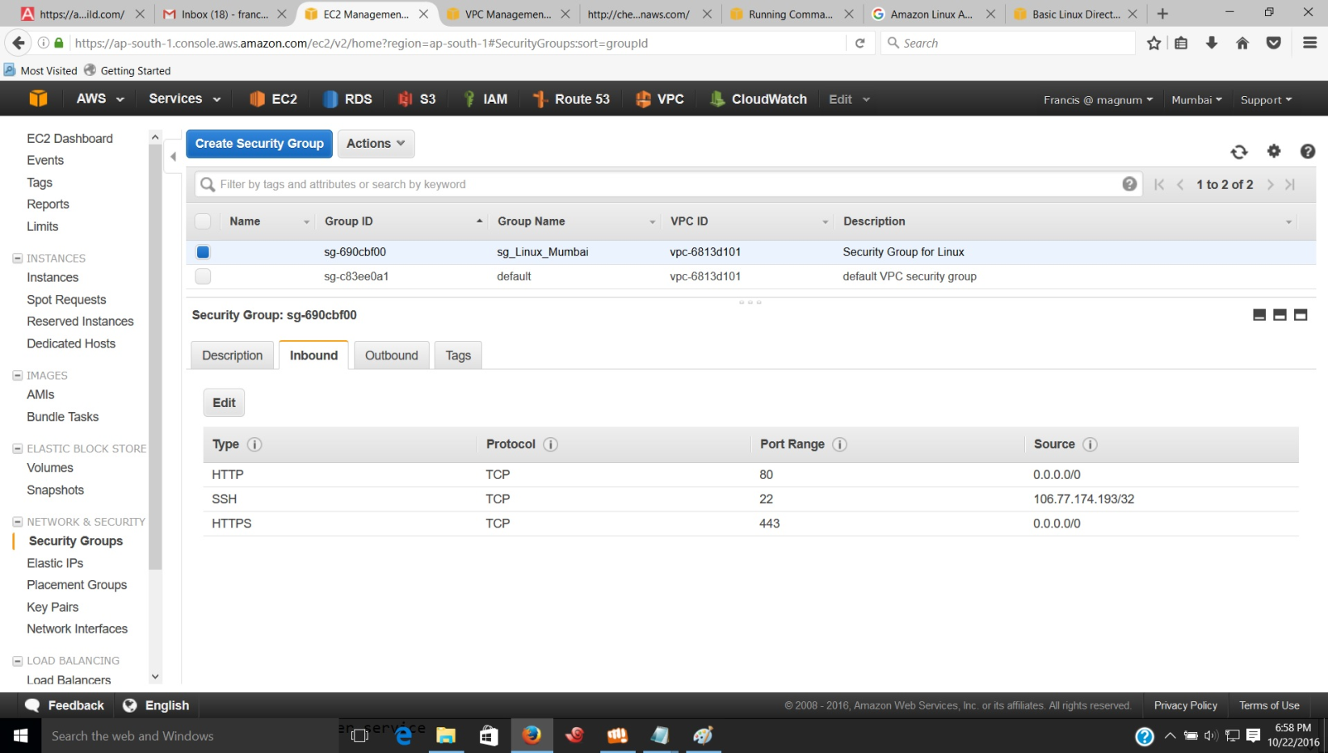

* **Steps to Launch an EC2 Instance with Cloud-init**

1. *Open the Amazon EC2 Console from the dashboard and choose ‘ Launch instance ‘ and select an Amazon Machine Image that supports Cloud-init.*
2. *Select an Instance Type on ‘ Step 2 : Choose an Instance Type ‘ page and click on “ Next : Configure Instance Details. “*
3. *On ‘ Step 3 : Configure Instance Details ‘ page modify the settings as required.Then provide the Cloud-init Directives into the User data filed to perform automated configuration tasks such as running scripts after starting the instance.*

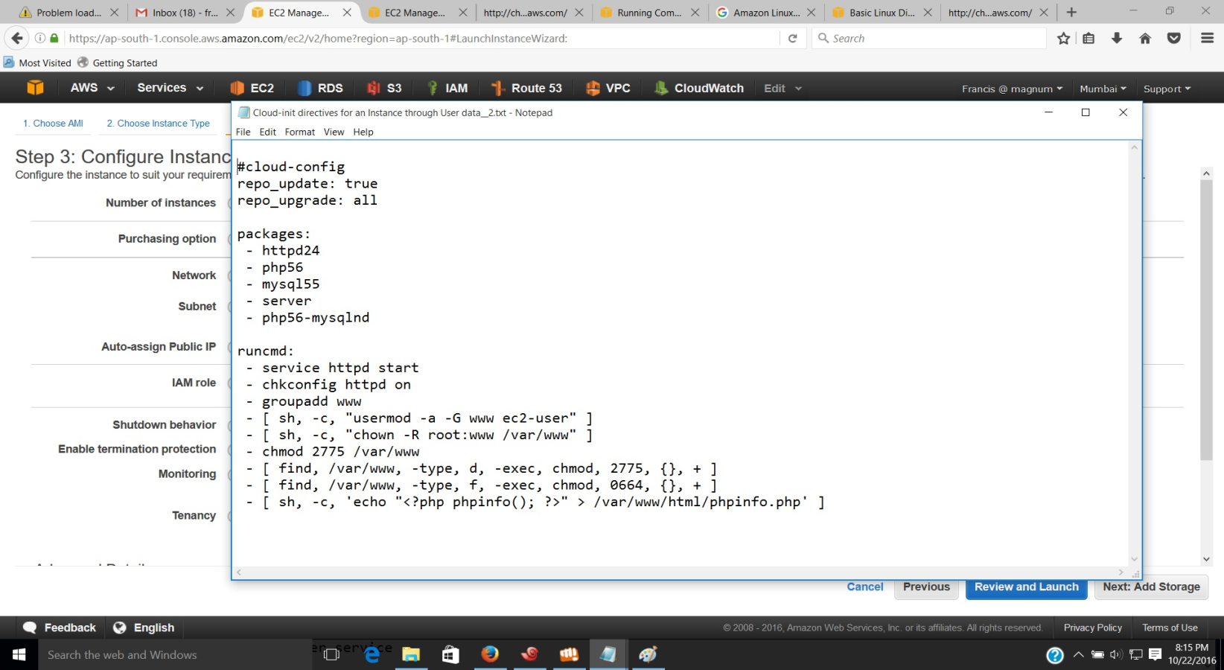

*As an alternative, after modifying configuration settings you can fill Shell script into the user data field instead of Cloud-init Directives. This script performs same automated configuration tasks such as Cloud-init Directives.*

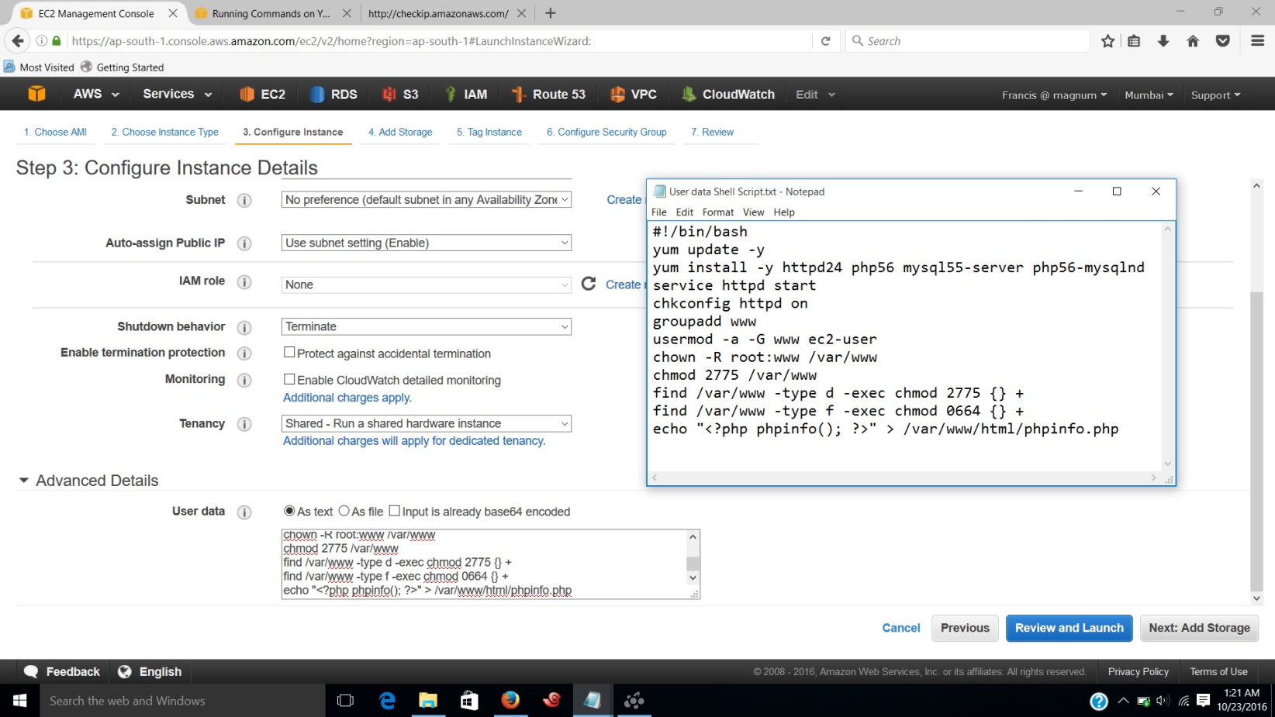

1. *On ‘ Step 4: Add Storage ‘ page, specify volumes to be attached to the instance besides the volumes specified by the AMI.*
2. *On ‘ Step 5: Tag Instance‘ page, specify* [*Name*](http://docs.aws.amazon.com/AWSEC2/latest/UserGuide/Using_Tags.html)*for the instance. Choose “ Next: Configure Security Group “ when you are done.*
3. *On the “ Step 6: Configure Security Group “ page, choosethe security group you have created to define firewall rules for your instance.*

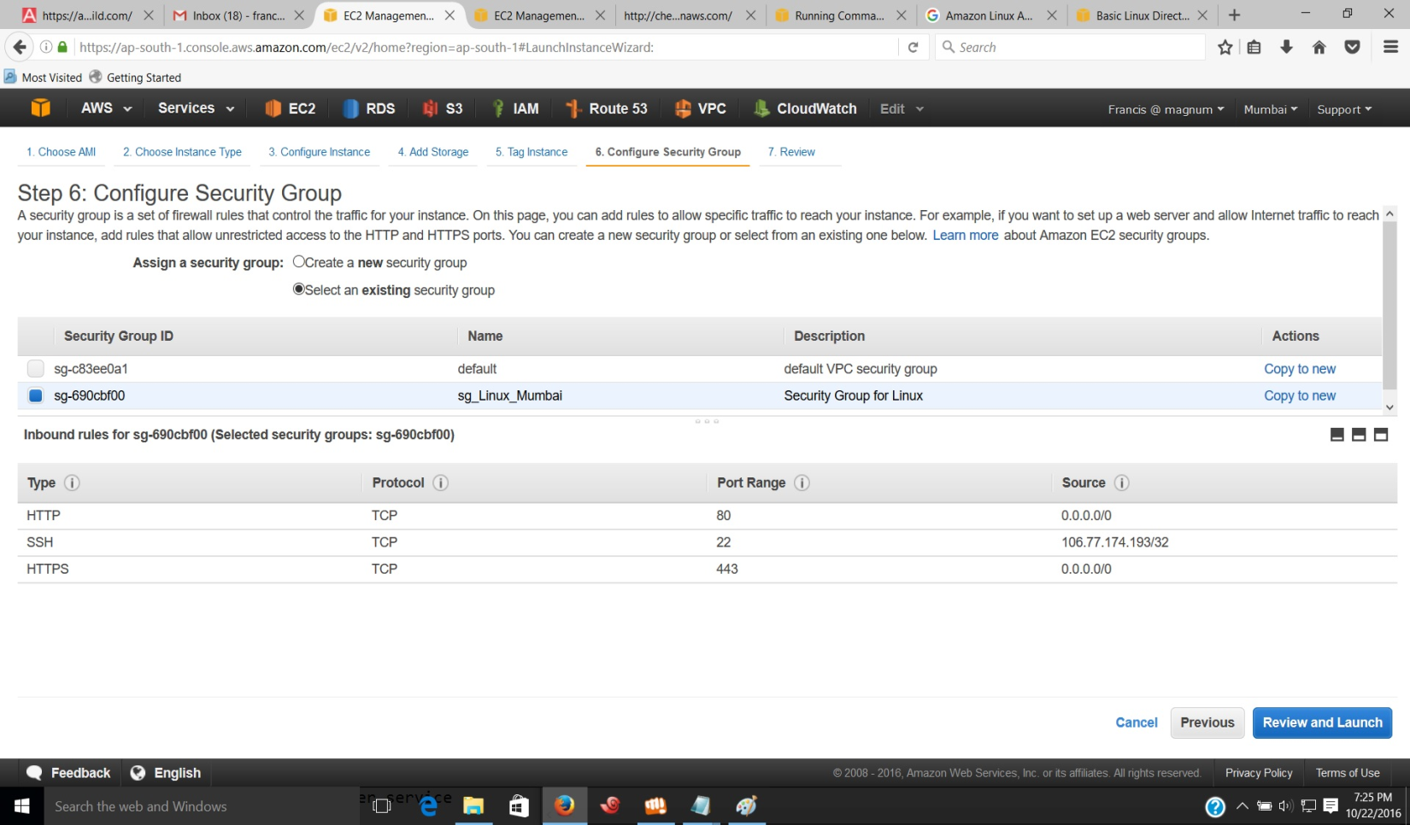

1. *In ‘Step 7: Review Instance Launch ‘ page, check the details of your instance, and make any necessary changes by clicking the appropriate Edit link. When you are ready, choose Launch.*

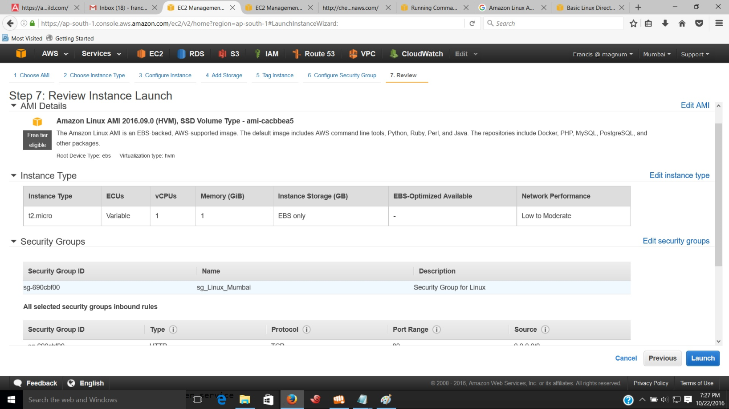

1. *In the ‘Select an existing key pair or create a new key pair‘ dialog box, provide key pair information and click on “ Download Key pair. “ Save the Key pair in a secure location. Then click on ‘Launch Instance.’*
2. *In the launch status page, id of launching instance is shown.*
3. *Click on the Instance id and you can see the details of the instance*.

* **Verifying whether Cloud-init directives completed the tasks**.

1. *You can verify whether Cloud-init directives completed the tasks by entering urls.*

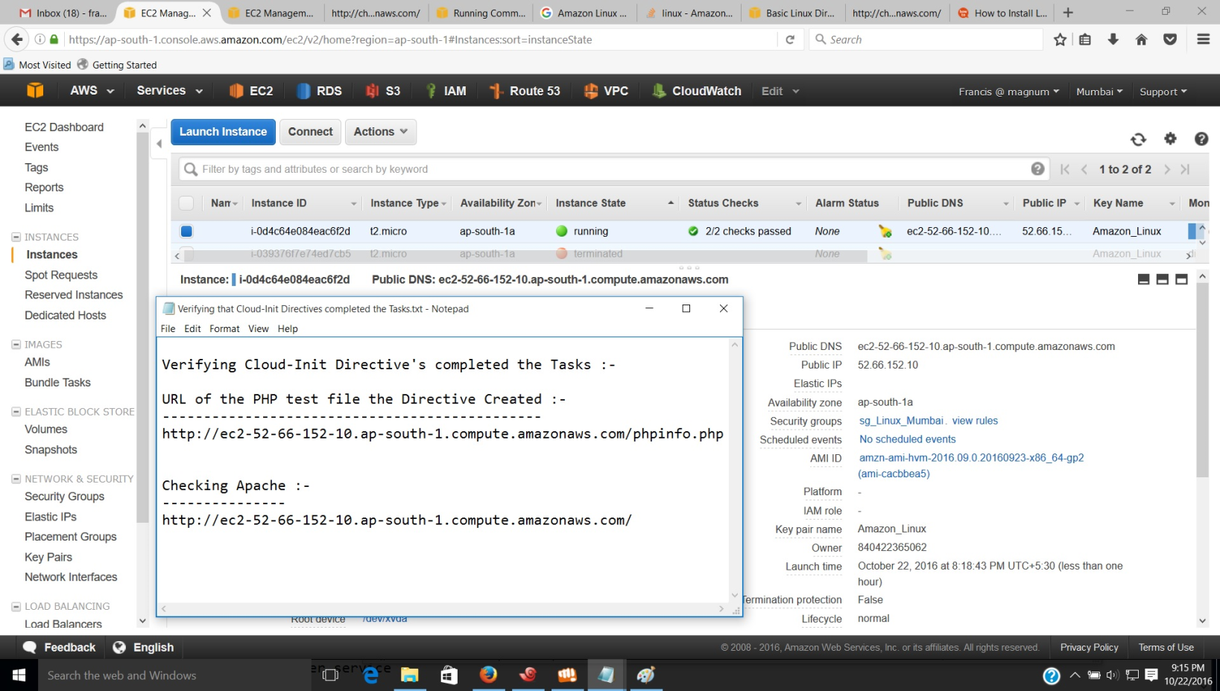

1. *Enter the URL of the PHP test file the directives created. It is the public DNS address of your instance followed by a forward slash and the file name of PHP test file.*

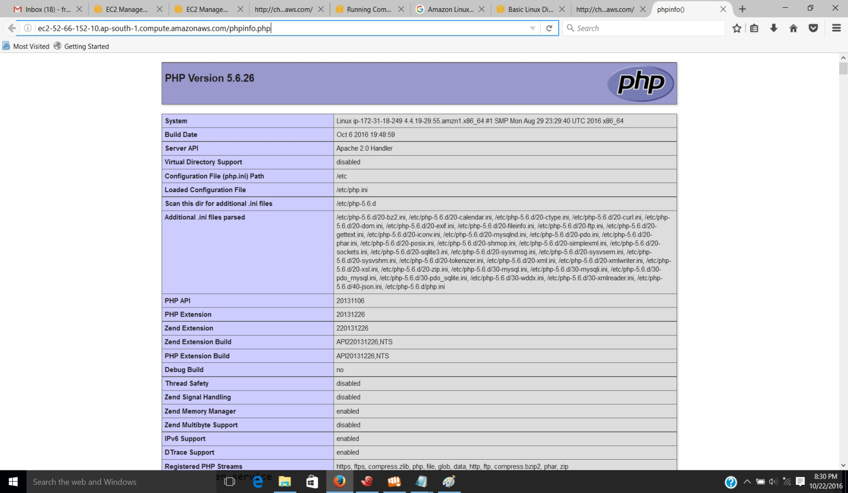

1. *Verify the location of the PHP test file by connecting to the Instance and going to the path of test file.*

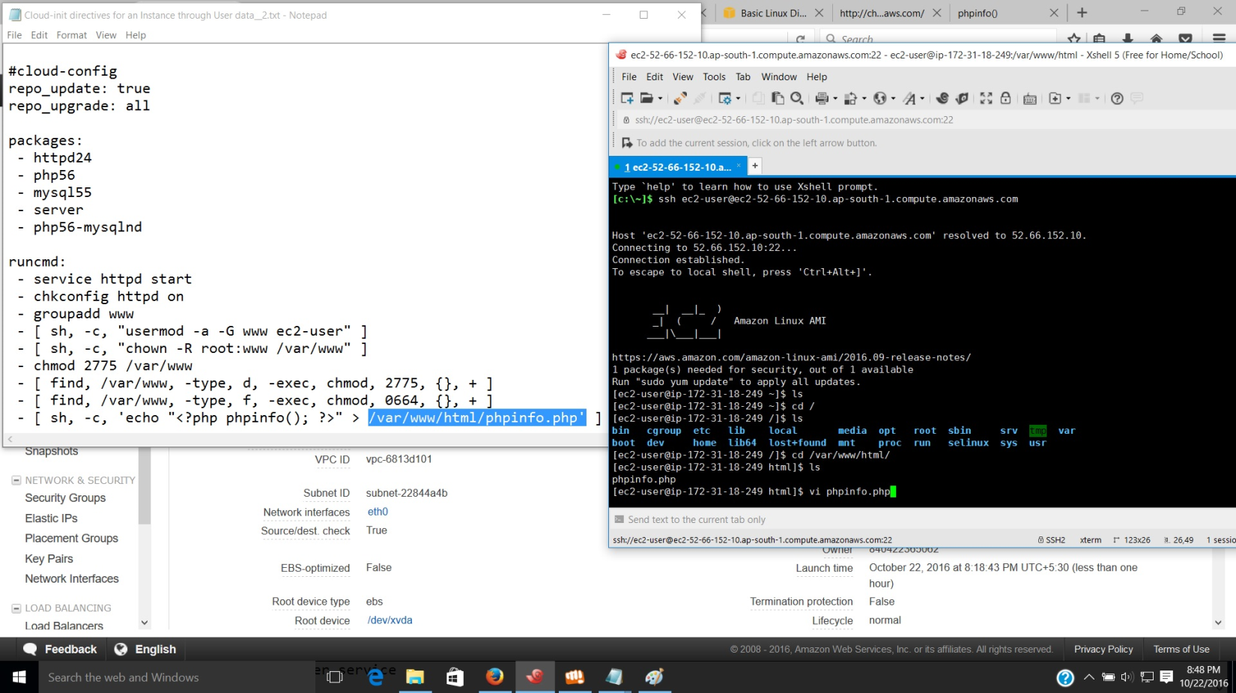

1. *Run the code in PHP without the need for creating a file*.

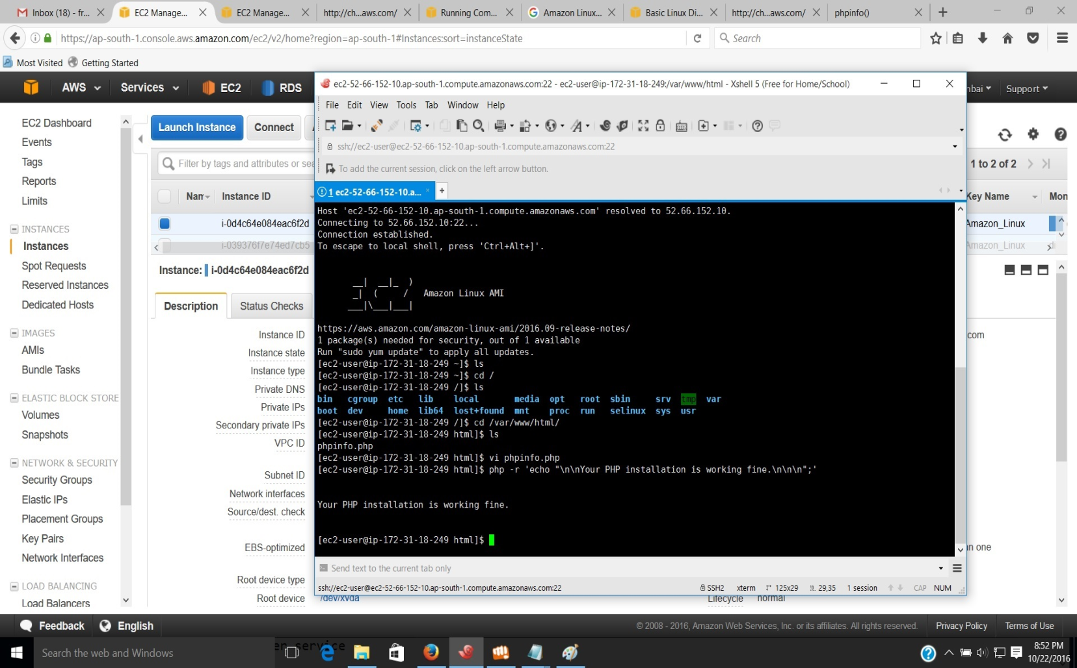

1. *Test page of Apache http server.*

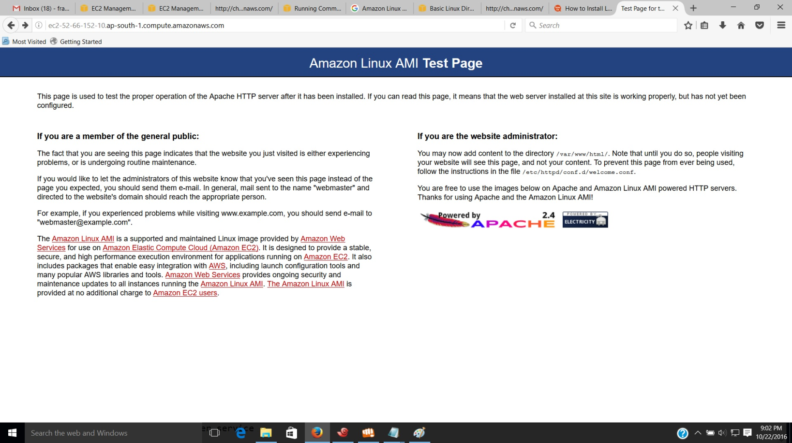

1. *Restarting Apache2 after installation of after the installation of both MySQL and PHP.*

